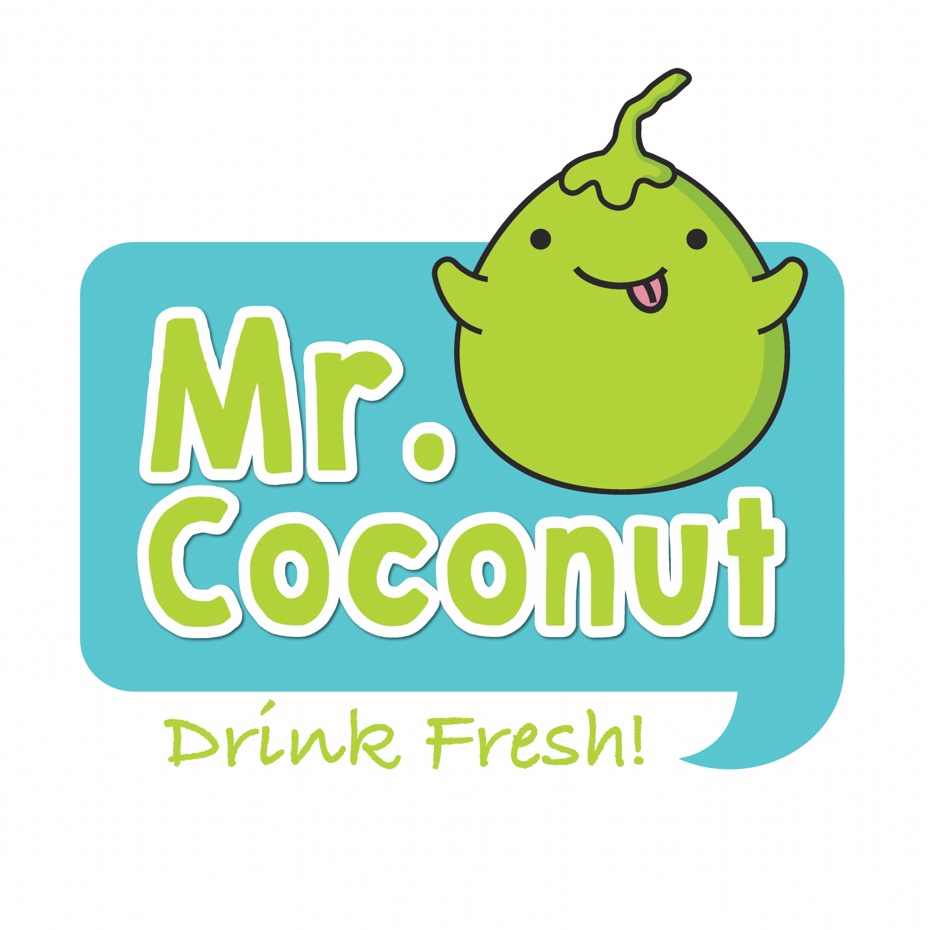**User Testing Report:**

**Mr Coconut Self-Kiosk UI/UX**

**Group 9: Layla, Yusri, Farhan, Chee Leong**

**Objective**

The primary objective of this user testing was to evaluate the usability, design, and functionality of the **Mr. Coconut.** The test aimed to identify any potential issues that users might encounter and gather feedback for improvements.

**Text Overview**

Target Audience: Youths & Young Adults

**Problems Identified**

User Interview Feedback:

* Customers reported that the kiosk flow was **slow and unresponsive.**
* They found the layout **lacking vibrancy** and the **digital photos of toppings unclear**, often requiring them to ask staff for clarification, which led to time delays.

Personal Inspection:

* We visited multiple Mr. Coconut outlets to **verify** the issues raised in user interviews.
* Our observations **confirmed** the accuracy of the feedback, with the identified issues—such as **slow kiosk flow, lack of vibrancy, and unclear toppings** representation—being consistent across the locations we inspected.

**Overall Task Overview**

Findings & Recommendations:

**1: (-) Navigation Complexity:** The main menu was confusing with too many clicks.

**(+) Recommendation:** Simplify the menu and reduce the number of sSteps to access primary services.

**2: (-) Help Section Visibility:**  The help section was hard to find.

**(+) Recommendation:** Improve visibility with icons or a dedicated button.

**3: (-) Functionality:** No back button was available for easy navigation.

**(+) Recommendation:** Add visible back buttons for smoother navigation.

Start Page:

* User Expectations: Easy tap-to-order functionality, **clear display** of accepted payment methods, and **visible accessibility** options.
* Observed Issues: Some users found the initial screen **unresponsive**, and the accepted payment methods were **not clearly highlighted.**

Order Placement:

* User Expectations: A **smooth and efficient process** for selecting drinks, with a pop-up feature for drink customization that **enhances the order flow.**
* Observed Issues: The customization pop-up was **slow to appear**, causing **delays** in the ordering process.

Payment Process:

* User Expectations: The ability to choose from **a variety of payment methods,** both local and international, and complete transactions *seamlessly.*
* Observed Issues: Users **encountered difficulties with the payment interface,** particularly with limited payment options, leading to incomplete transactions.

Order Number Collection

* User Expectations: Receipt of a queue number and a QR code for drink collection, **designed to manage crowd dispersal** and ensure an orderly pick-up process.
* Observed Issues: Some users reported that the queue number and QR code system was not intuitive, **leading to confusion** during order collection.

**Prepared by:**

Group 9 - Layla, Yusri, Farhan, Chee Leong.

22/08/24.

**END OF REPORT.**